Chapter 35.1 The Reptile Body - Characteristics of Reptiles

Strong bony skeletons

Two pairs of legs
- Legs are positioned under the body frame vertically allowing for greater ease of movement on land

Toes with claws
- Allows for climbing and digging, grip the ground allowing for high speed movement

Nervous System with relatively small brain
- Can still perform complex behaviors (including elaborate courtship rituals)

Ectothermic Metabolism (Cold-blooded)
- Can not generate heat, must regulate body temperature by absorbing heat from their environment by basking in the sun, or cooling off by seeking shade
- Become sluggish in cold temperatures and may be unable to function. Need for warmth limits range of habitats, reptiles living in temperate zones (areas with seasons) will hibernate in the winter months.

Water-tight skin
- Prevents water loss though skin allowing for land habitation.

Water-tight eggs
- Provides moist environment for embryo growth
- Amnionic egg - contains water and food supply for developing embryo

Respiration using lungs
- All oxygen is obtained through the lungs (no “skin breathing”)
- Alveoli - grape shaped chambers within the lungs that increase the surface area allowing for increased gas exchange
- Muscles attached to the rib cage increase the air flow to and from the lungs

Double-loop circulation
- Blood flows from heart to lungs to heart, then heart to body to heart

Internal Fertilization
- Oviparous Reptiles: young hatch from eggs laid in the habitat and incubated by heat from the environment, eggs are usually NOT protected by parents
- Ovoviviparous Reptiles: eggs incubate inside the female body until shortly before hatching (some species hatch within the female body)

Chapter 35.2 Today’s Reptiles

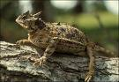
Lizards (order Squamata)
- Includes iguanas, chameleons, geckos, anoles, and horned lizards (sometimes mistakenly referred to as “horny toads”)
- Most are small by some can grow as long as 10 feet in length (ex. Komodo Dragon)
- Some do not have vertebrae in their tail, allowing them to “loose” the tail and regrow it if needed

Snakes (order Squamata)
- May have evolved from lizards, share many similar characteristics making it difficult to distinguish between snakes and legless lizards
- Skeleton characteristics
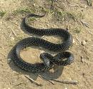
  - No pectoral girdle
  - Flexible jaw with 5 point movement that allows snakes to consume food larger then their head
- Three methods of killing prey
  - Seize prey and swallow it whole
  - Suffocation by squeezing prey
  - Venom injected from fangs poisons the prey
- Some snakes are dangerous to humans
  - Cobras, Kraits, and Coral snakes
  - Sea snakes
  - Rattlesnakes, Water Moccasins, and Copperhead snakes (found in Mississippi)

Turtles and Tortoises (class Chelonia)
- Body is incased in a hard, bony, protective shell
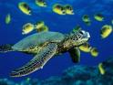
  - Many can pull their head back into the shell for protection
  - Most have a dome shaped shell, but some water-dwelling species have a flat, streamlined shell that allows for greater maneuverability
  - Shell Design
    - Fused plates of bone covered with horny shields of leathery skin
    - 2 parts
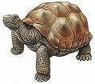
      - Carapace: dorsal portion of shell to which vertebrae and ribs may be fused
      - Plastron: ventral portion
    - Provides support for all muscle attachment
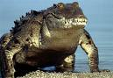
- Jaws but no teeth
  - Sharp plates form a beak-like shape and function
  - Herbivore

Crocodiles and Alligators (class Crocodilia)
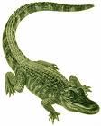
- Most closely related to dinosaurs of all living animals
- Aggressive carnivores
  - capture prey by stealthily sneaking in or lying in wait, once seized prey is drug down into the water to be drowned and eaten
  - Special valve in the back of the neck prevents water from entering the airway while eating
- Can grow very large, up to 20 feet or more
- Eyes located high on the sides of the head and nostrils located on the top of the snout allow these animals to see and breathe while otherwise submerged in the water
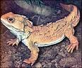
- Lay eggs and care for the young after hatching for up to a year

Tuataras (genus Sphenodon)
- Only two living species remain
- Lizard-like reptiles that can grow up to 2 feet long
- Unique because they can remain active even in low temperatures
- Feed on insects, worms, and small animals at night
- Called the “living fossil” because it has remained unchanged for 150 million years
- Numbers are declining due to loss of habitat

Chapter 35.3 Characteristics of Birds (class Aves)

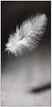
Feathers
- Modified scales that develop from tiny pits called follicles; shed (molt) from time to tome to replace
- Provide lift for flight
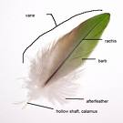
- Conserve body heat
- “Contour Feathers” - cover the body and give adult birds their shape, specialized contour feathers called “flight feathers” are fount on the wings and tail
- “Down Feathers” - cover the body of young birds and are found under the contour feathers of the adult bird. Soft and fluffy, these feathers provide insulation for the bird.
- Preening - process of smoothing and grooming the feathers
- Preen Gland - produces oil that waterproofs the feathers, coats feathers while preening

Skeleton
- Bones are strong but light weight, thin & hollow construction with many bones fused for strength at muscle attachment sites
- Enlarged breast bone accommodates strong breast muscles used for flight or swimming
- Fused collarbones (wishbone) also accommodate flight

Endothermic Metabolism
- Metabolic activities produce enough heat to regulate body temperature
- High rate of metabolism leads to relatively high body temperature (104° - 108° F)

Completely Divided Ventricle
- Oxygen rich and oxygen poor blood are kept separate
- Sinus Venus no longer own chamber but rather part of the right atrium serving as the trigger of the heartbeat (pacemaker)
- 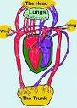

Highly Efficient Lungs
- One Way Air Flow (p797)
  - Only fully oxygenated air passes through lung tissue
  - Blood passes lung tissue in a somewhat countercurrent flow
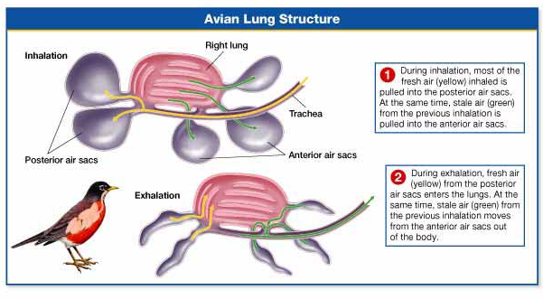

Special Adaptations (p800-802)
- Beaks, legs, and feet are adapted for their environment
- Body Shape adapted for survival (such as the water hunter birds)
- Eyes are adapted for night vision in nocturnal hunters (owls)



